Article 6 — The Telemetry Problem
Michal Doroszewski
You’re driving a rental car that seems fine. The engine starts. The brakes work. The dashboard glows with the reassuring green light of SYSTEM OK. You merge onto the highway, set the cruise control, and settle in for a smooth ride. Then the car begins to drift.
Not dramatically. Just enough to make you glance at the alignment. You tap the steering wheel. It responds. You check the dashboard. Still SYSTEM OK. You open the app that came with the rental. It shows your location, your speed, and a cheerful message that says, “Telemetry active.”
Then the car swerves.
You pull over. You call support. They ask if you’ve checked the app. You say yes. They ask if the app shows any errors. You say no. They ask if the SYSTEM OK light is still green. You say yes. They pause, then say, “The system decides these things. It’s complicated.”
You haven’t changed. The car hasn’t changed. The road hasn’t changed. The only thing that changed was the telemetry’s ability to see what was happening.
That is the Telemetry Problem. Not the sensor‑failure kind — the architectural kind. The kind that appears when cloud systems are asked to optimize, troubleshoot, and protect workloads they cannot fully observe. The kind that makes dashboards look confident while the system underneath quietly loses context.
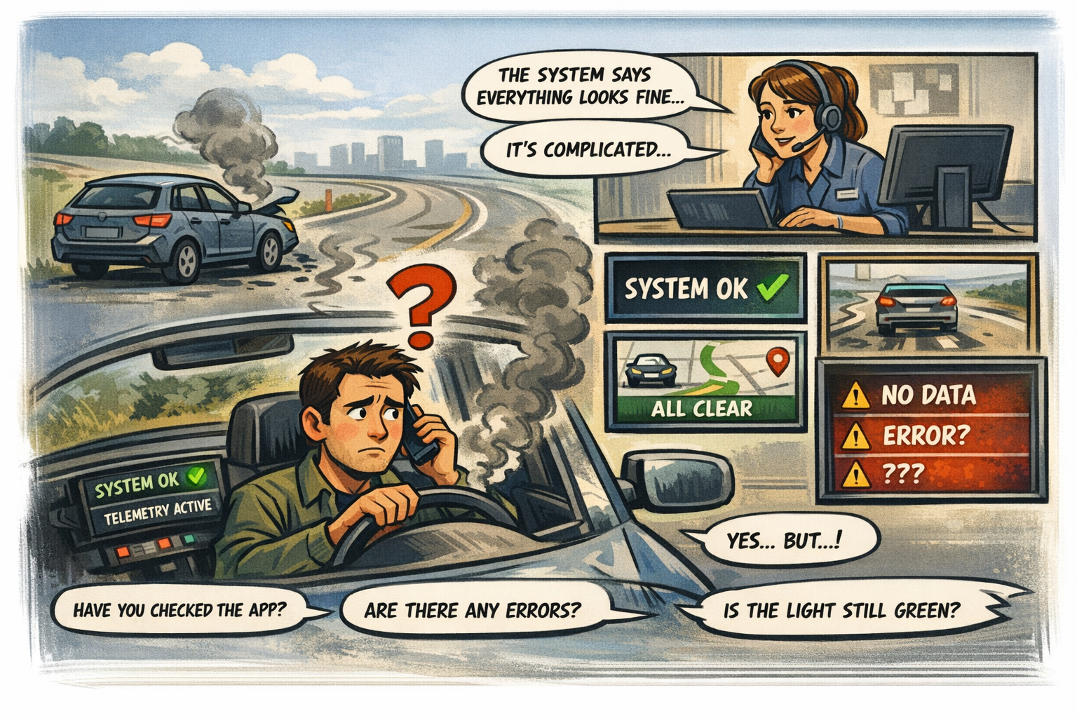
<<Comic Image Inserted Here>>
How Telemetry Became the Cloud’s Nervous System
Cloud systems rely on telemetry the way the body relies on nerves. Every signal matters. Location, timing, session continuity, risk, region, media flow — all of it is measured, interpreted, and acted upon in real time. Telemetry is how the cloud understands the environment it’s operating in. It’s how identity evaluates trust. It’s how Conditional Access enforces policy. It’s how dashboards explain behavior. Without telemetry, the cloud is just guessing.
In Commercial environments, telemetry is rich, continuous, and deeply integrated. In GCC‑Moderate, it’s restricted, delayed, and often missing entirely.
Why GCC‑Moderate Starves the Cloud of Visibility
The FedRAMP Moderate boundary was designed to protect sensitive workloads. It was not designed to carry modern telemetry. As a result, many of the signals cloud systems depend on are blocked, delayed, or distorted.
Risk scoring doesn’t arrive. Region selection is misinterpreted. Token anomalies go undetected. Session instability is invisible. Device trust failures are misclassified. Dashboards show symptoms without causes. Logs show events without context. Administrators see patterns that don’t make sense because the architecture prevents the cloud from seeing what it’s reacting to.
The cloud isn’t malfunctioning. It’s operating with partial information.
Why Headquarters and Field Offices See Different Dashboards
Headquarters sits close to cloud egress and identity controllers. Field offices sit behind WAN optimizers, MPLS circuits, and inspection layers. Headquarters sees clean telemetry. Field offices see distorted signals.
Dashboards in headquarters show stability. Dashboards in field offices show anomalies. Both are technically accurate. Neither tells the full story. The architecture creates two realities — one visible, one obscured — and the dashboards reflect the truth they’re allowed to see.
Why Troubleshooting Feels Like Guesswork
When telemetry is missing, every team falls back to the tools they do have. Network teams rely on packet capture. Security teams rely on logs. Cloud teams rely on dashboards. Help desks rely on user reports. Each tool shows a different slice of the truth. None show the whole picture.
Fixes work in headquarters but fail in field offices. Improvements appear promising in testing but collapse in production. Sessions behave differently depending on which signals arrive and which ones don’t. The system isn’t broken. It’s blindfolded.
Why Modernization Efforts Stall Without Telemetry
Modernization depends on feedback. Without telemetry, there is no feedback. Teams cannot evaluate performance, diagnose failures, or enforce policy. Zero Trust becomes guesswork. Optimization becomes trial and error. Leadership hears conflicting reports that are all true but incomplete.
This is not dysfunction. It is instrumentation mismatch. The architecture hides the signals modernization depends on.
The Root of the Telemetry Problem
The telemetry problem is not caused by misconfiguration, neglect, or lack of effort. It is caused by boundaries that were designed before telemetry mattered. The FedRAMP Moderate boundary restricts the very signals cloud systems were built to use. Identity, security, and performance all suffer because the architecture cannot see what the cloud is doing.
You cannot enforce policy without visibility.
You cannot troubleshoot symptoms without context.
You cannot optimize behavior you cannot observe.
You cannot modernize a system that cannot see itself.
The Only Way Forward
Telemetry must be restored. Not simulated. Not approximated. Restored.
The boundary must allow the signals cloud systems depend on. Risk scoring. Region awareness. Session continuity. Device trust. Media flow. Real‑time diagnostics. Only then can dashboards reflect reality. Only then can teams troubleshoot effectively. Only then can modernization become something other than a guessing game.
Visibility is not a feature. It is a prerequisite.
About the Author
Michal Doroszewski
Michal Doroszewski is a technology strategist focused on cloud architecture, identity platforms, and federal modernization. He writes about the structural and architectural forces that shape government IT, translating complex technical constraints into clear, accessible narratives for leaders and practitioners.

